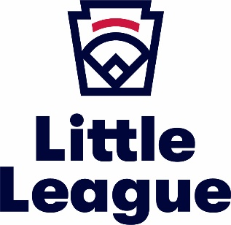
NEWS RELEASE

Place Local League
or District Logo
& URL here

For immediate release MONTH DATE, YEAR

Headline About Your Event

NAME OF YOUR TOWN, STATE NAME. (MONTH DATE, YEAR) – A ONE-PAGE (TWO IF NECESSARY) SUMMARY OF YOUR EVENT, WHY IT WAS IMPORTANT, WHO CAME AND WHO IT WAS FOR. YOU SHOULD ALWAYS INCLUDE A QUOTE, WHICH CAN COME FROM A LEAGUE OFFICER, DIGNITARY OR SOMEONE WHO ATTENDED THE EVENT.

About Little League®
Founded in 1939, Little League® is the world’s largest organized youth sports program, with approximately two million players (ages 4-16) playing baseball and softball in communities across every U.S. state and more than 80 other countries. Operated by more than one million volunteers, Little League believes in the power of youth baseball and softball to teach life lessons that build stronger individuals and communities. From professional athletes and award-winning celebrities, to public officials and other influential members of society, Little League graduates have taken the lessons they learned, both on and off the field, to create the next chapter of the Little League story. Each year, millions of people follow the hard work, dedication, and sportsmanship that Little Leaguers® display at our seven baseball and softball World Series events, the premier tournaments in youth sports. For more information, visit LittleLeague.org, and follow Little League (@LittleLeague) on Facebook, Twitter, Instagram, and YouTube.

###
For more information contact:

YOUR LEAGUE CONTACT INFORMATION (NAME, TITLE, PHONE, EMAIL AND LEAGUE WEBSITE) HERE THAT WOULD HANDLE QUESTIONS FROM THE MEDIA

